|  |  |
| --- | --- |
|  | Faculty of Information Science and Technology  Universiti Kebangsaan Malaysia  43600 Bangi Selangor |
| **TTTK2103**  **Computer Network Technology** | |

**PACKET TRACER**

2.7.6 Packet Tracer - Implement Basic Connectivity

|  |  |
| --- | --- |
| **Name** | **Matrix Number** |
| Mariam binti Masuan | A182976 |
| Mohamad Saiful Nizam bin Abd Aziz | A179830 |

**2.7.6 Packet Tracer - Implement Basic Connectivity**

**Part 1: Perform a Basic Configuration on S1 and S2**

**Step 1: Configure S1 with a hostname.**

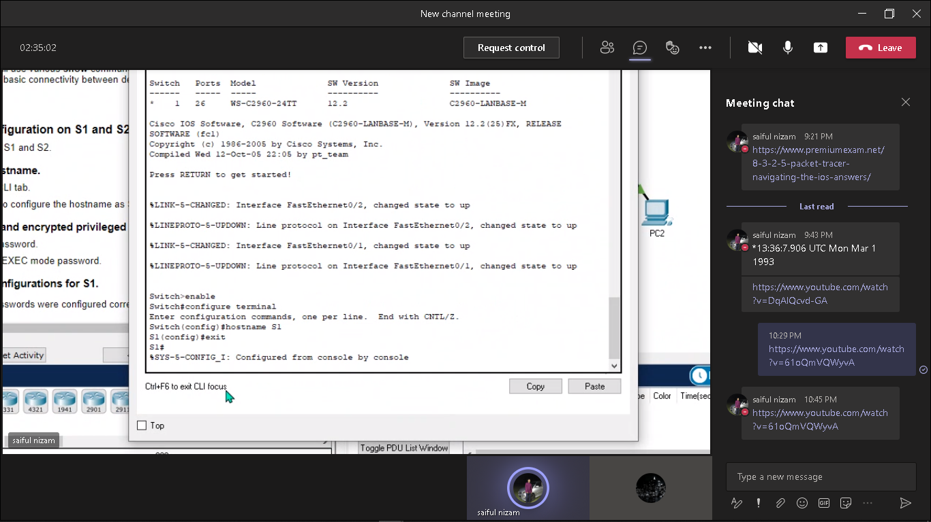

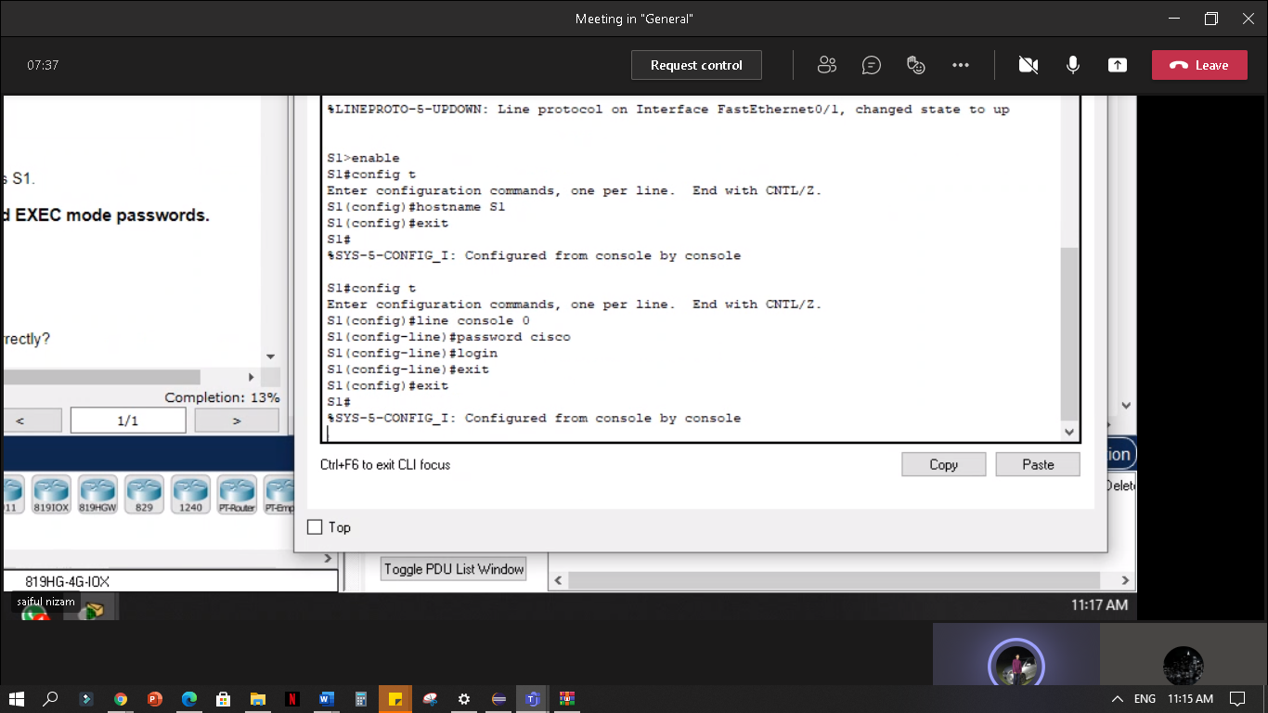 **Step 2: Configure the console and encrypted privileged EXEC mode passwords.**

**a.**

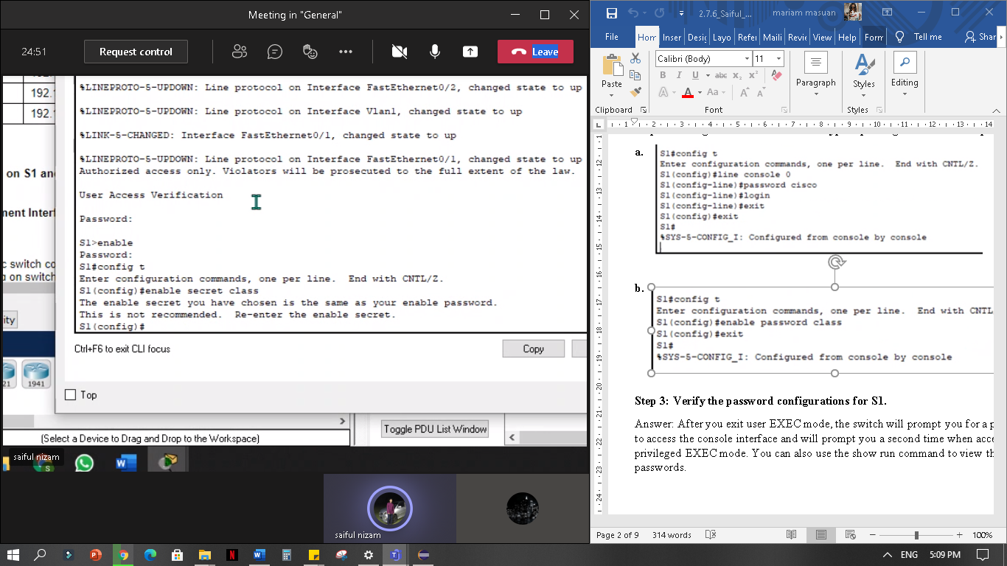**b.**

**Step 3: Verify the password configurations for S1.**

Answer: After you exit user EXEC mode, the switch will prompt you for a password to access the console interface and will prompt you a second time when accessing the privileged EXEC mode. You can also use the show run command to view the passwords.

**Step 4: Configure a message of the day (MOTD) banner.**

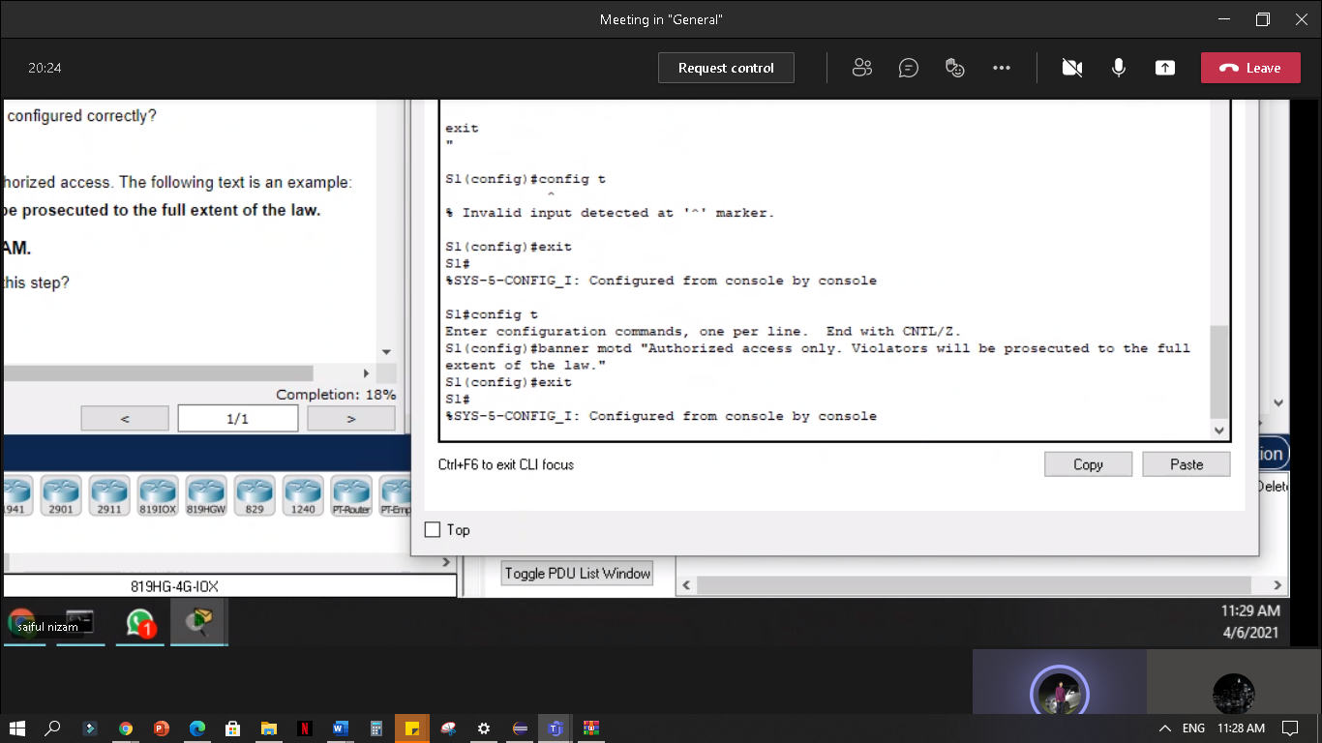

**Step 5: Save the configuration file to NVRAM.**

**Which command do you issue to accomplish this step?**

Answer: S1(config)# exit (or end)

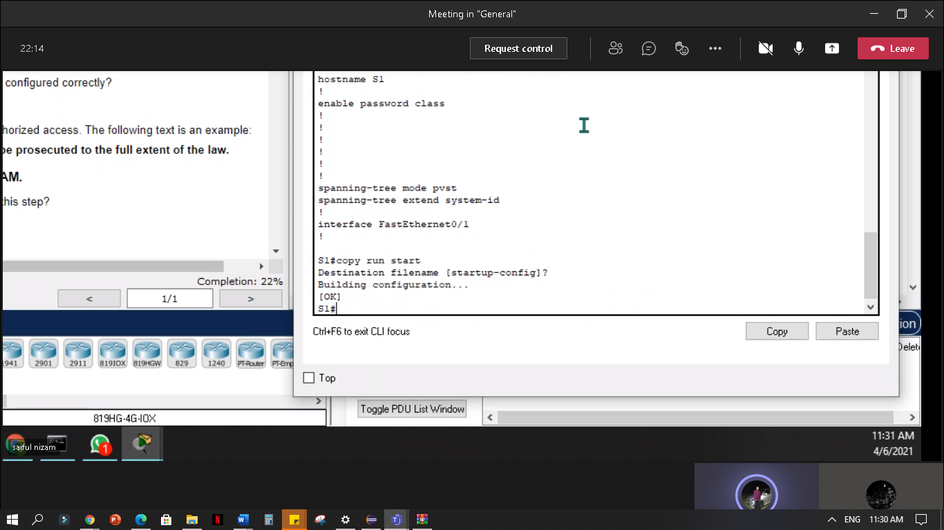 S1# copy run start

**Step 6: Repeat Steps 1 to 5 for S2.**

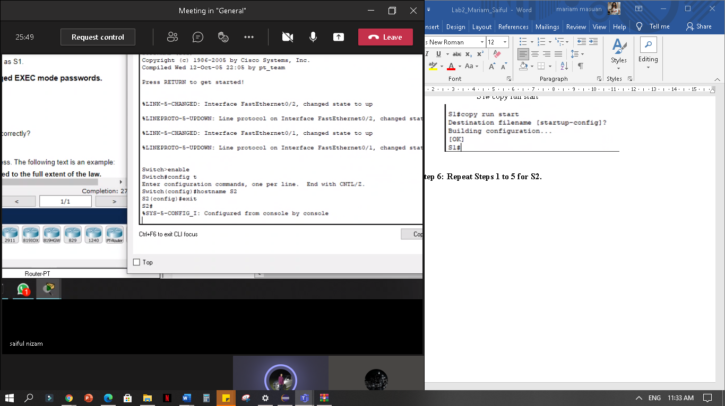

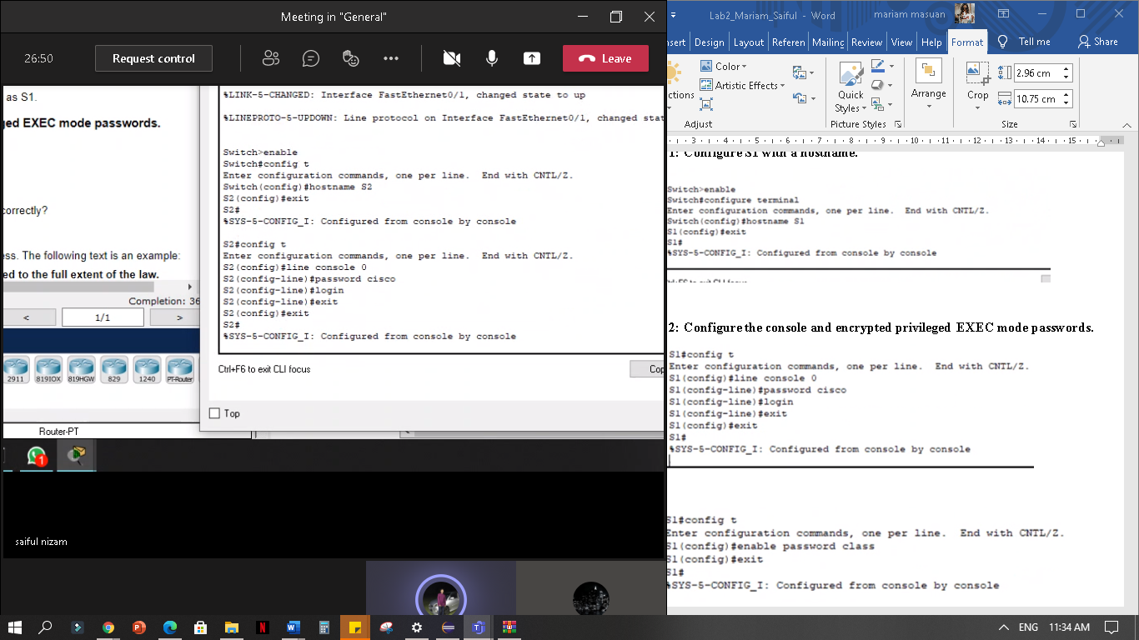

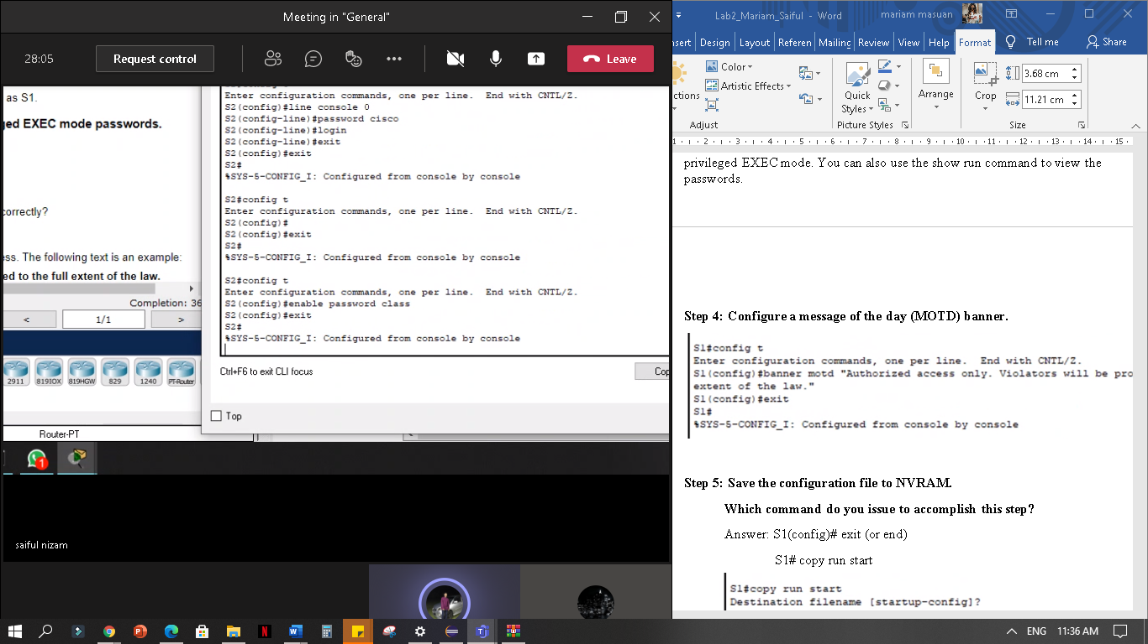

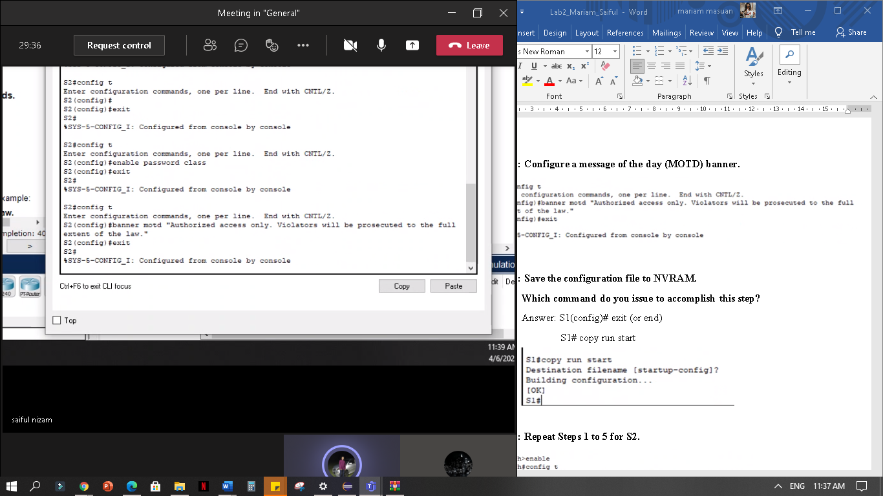

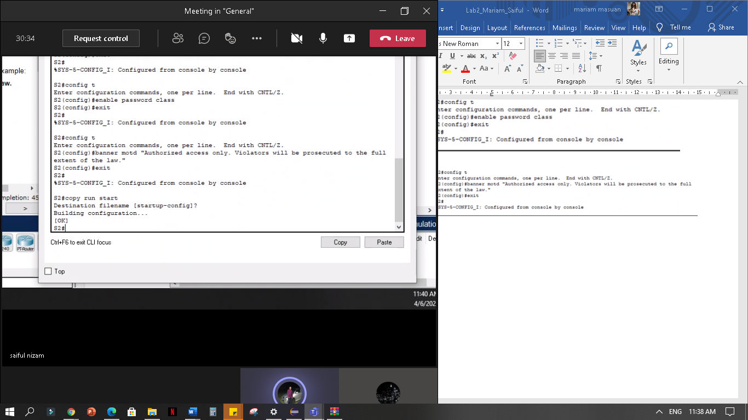

**Part 2: Configure the PCs**

**Step 1: Configure both PCs with IP addresses.**

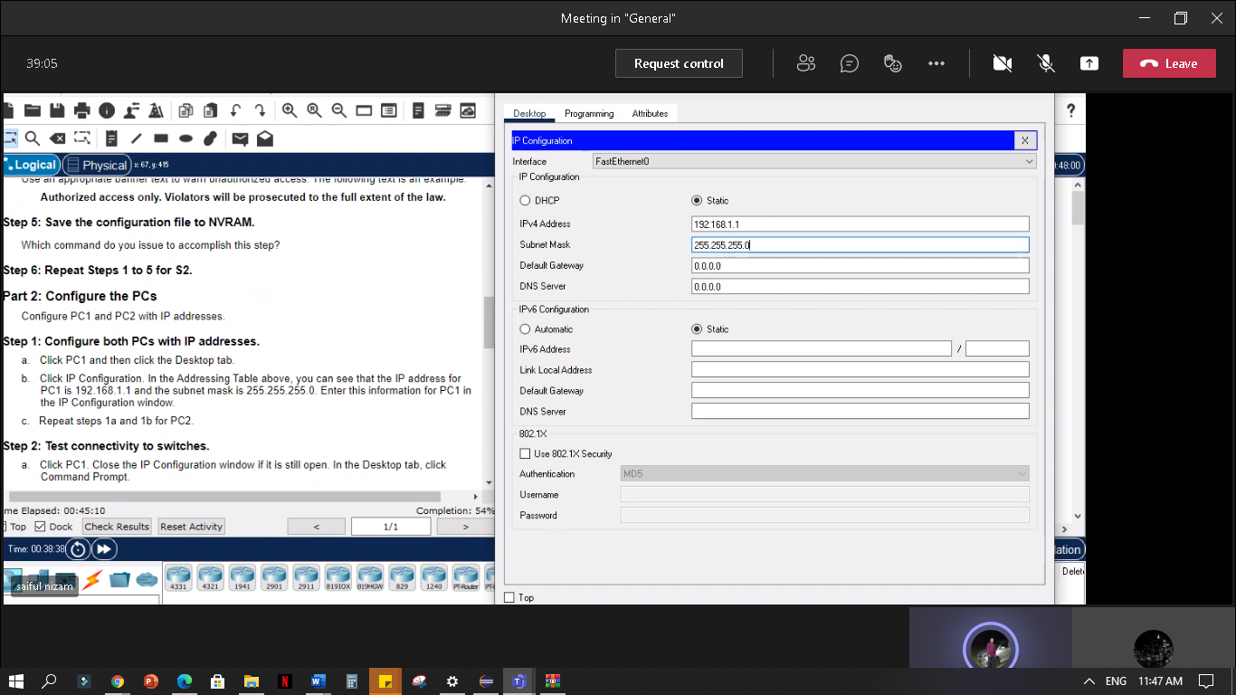PC1:

PC2:

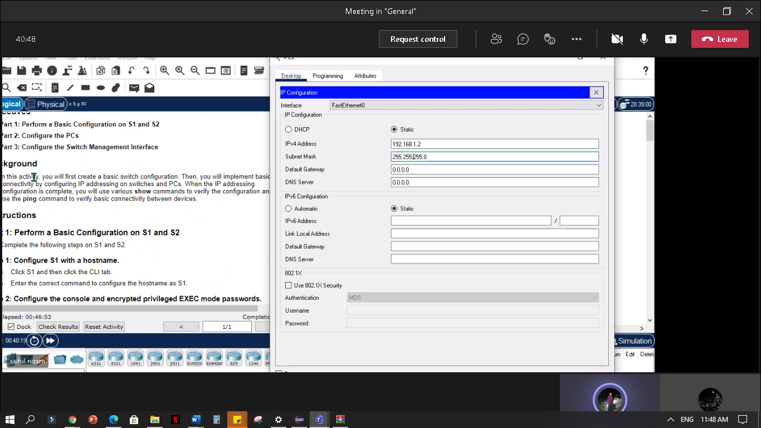

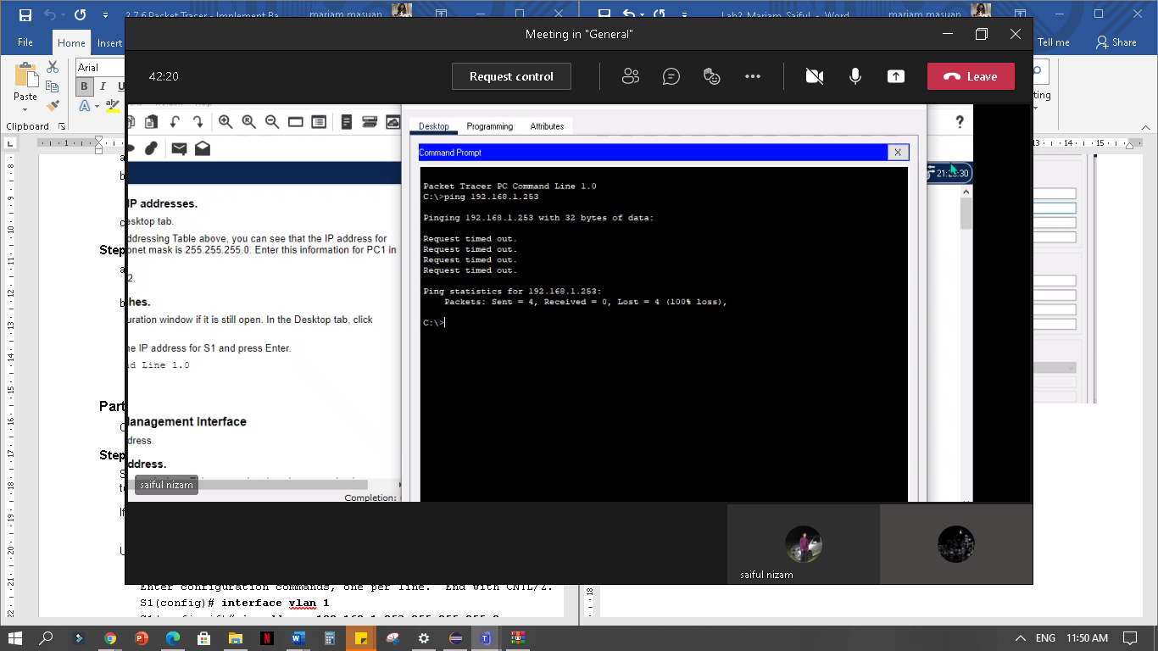 **Step 2: Test connectivity to switches.**

**Were you successful? Why or why not?**

Answer: Your ping should have been unsuccessful because the switches have not been configured with an IP address.

**Part 3: Configure the Switch Management Interface\**

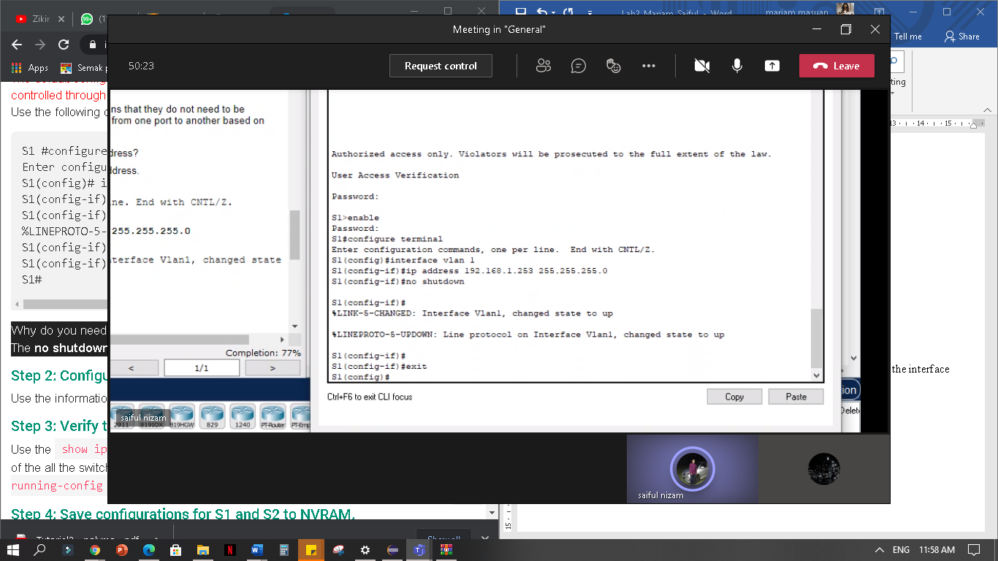 **Step 1: Configure S1 with an IP address.**

**Why do you need to enter the no shutdown command?**

Answer: The no shutdown command administratively places the interface in an active state.

**Step 2: Configure S2 with an IP address.**

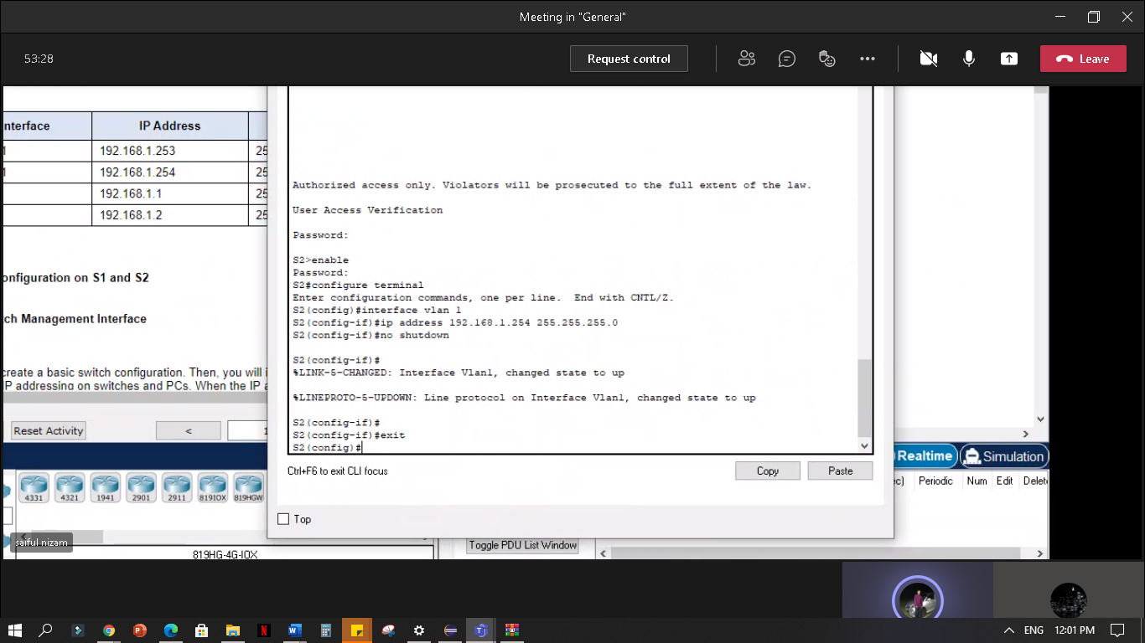

**Step 3: Verify the IP address configuration on S1 and S2.**

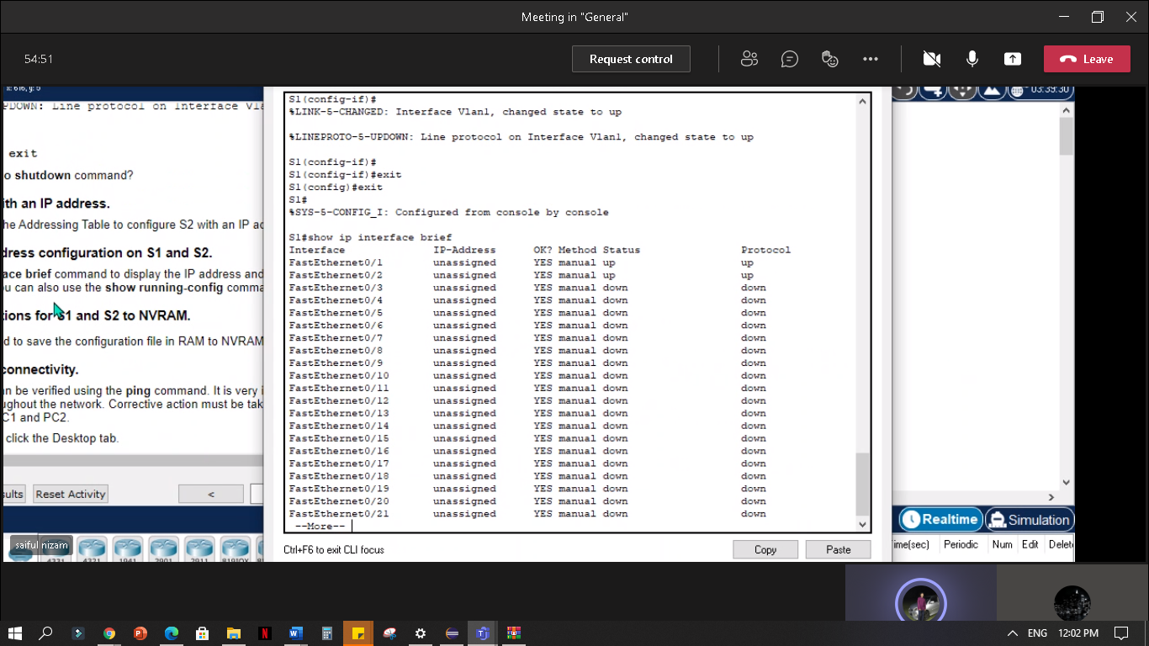S1:

S2: 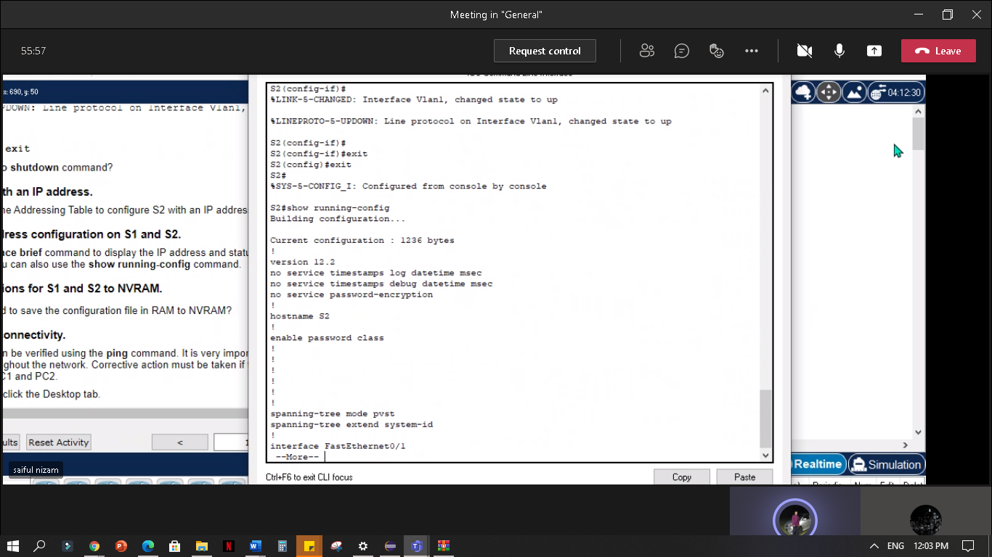

**Step 4: Save configurations for S1 and S2 to NVRAM.**

S1: 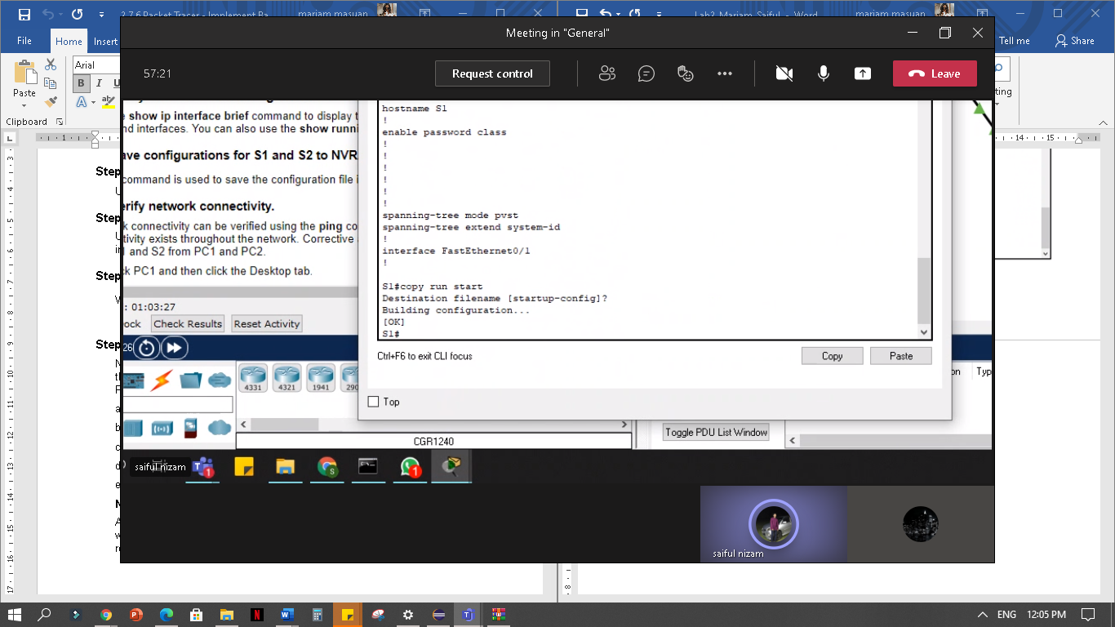

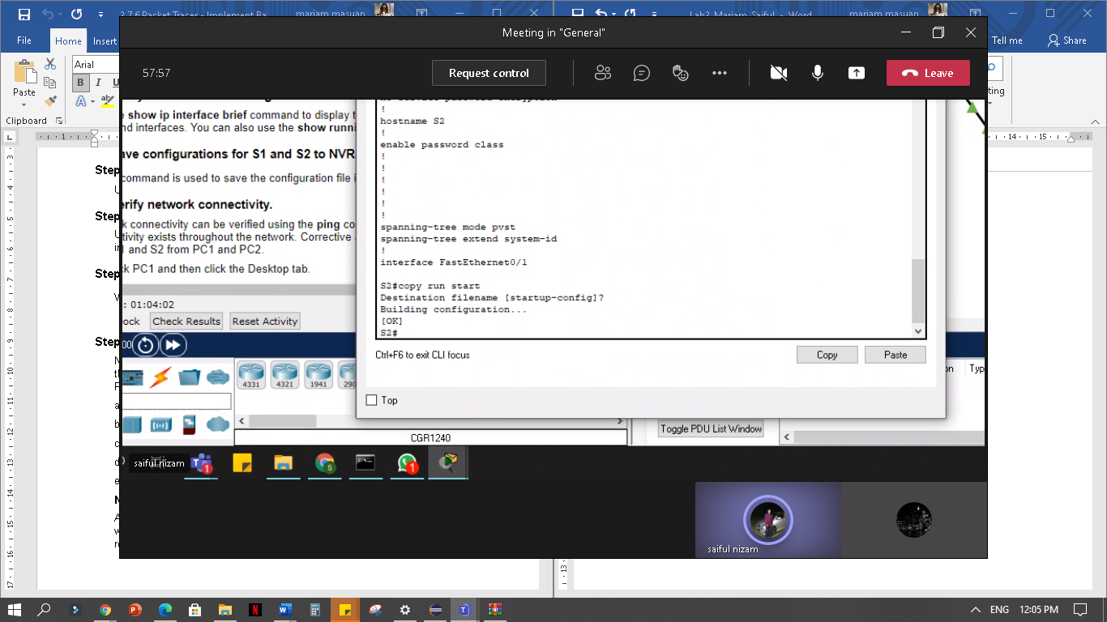

S2:

**Step 5: Verify network connectivity.**

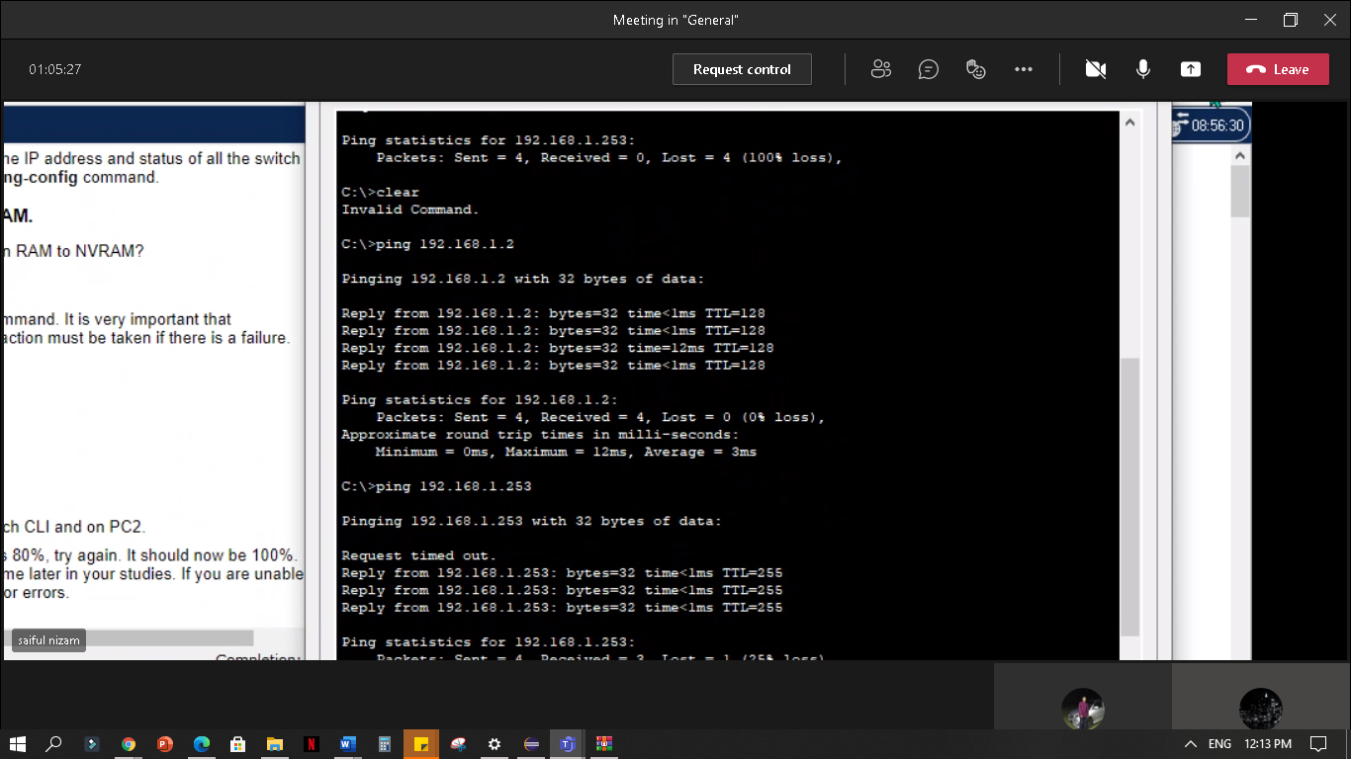 **c.Ping the IP address for PC2.**

**d.Ping the IP address for S1.**

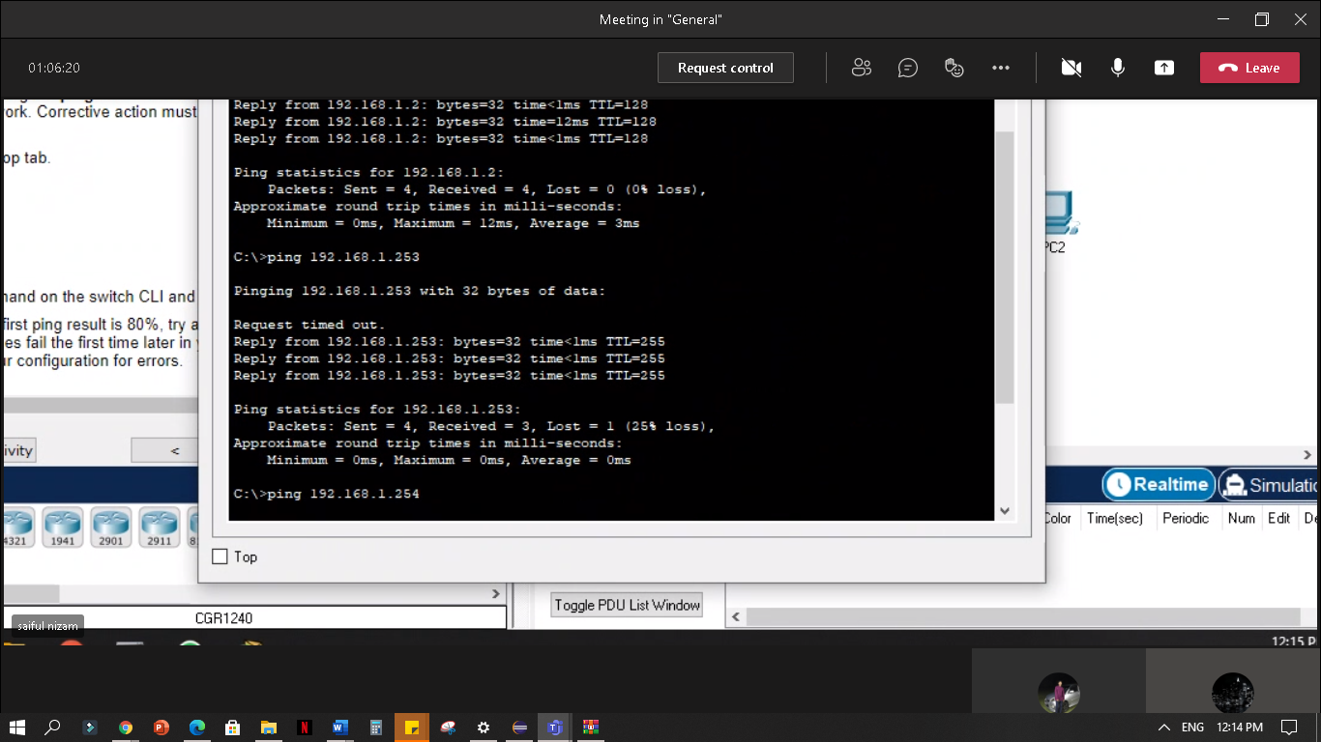

**e.Ping the IP address for S2.**

